SPECTATOR INFORMATION FOR VISITING WEMBLEY STADIUM

MATCH | UEFA EURO 2020 Qualifier - England V Bulgaria
DATE | Saturday 7th September 2019
VENUE ADDRESS | Wembley Stadium connected by EE, Wembley, London, HA9 0WS
KEY TIMINGS | Hospitality Doors Open 14:00  Stadium Doors Open Teams Warm Up 15:30 16:15  Kick Off Scheduled Match Finish 17:00 18:45*  *No extra time or penalties apply for this fixture
AGE RESTRICTIONS | - Guests aged under 14 must be accompanied by an adult over the age of 18  - Children under 2 years will not be permitted access in to the stadium for any event.
SAFETY AND SECURITY | Please note there will be enhanced security searches in place for this match and all supporters need to be aware of:  - No under 2s are  - We strongly advise that all supporters arrive at the stadium no later than 1 hour prior to kick-off.  - Wembley Stadium operates a restricted bag policy  - Bags larger than an A4 piece of paper (when layed flat) will not be permitted entry  - If you need to bring certain items or equipment for medical reasons, please visit https://help.wembleystadium.com/support/home before match day to request a medical exemption certificate which you will need to bring with you.  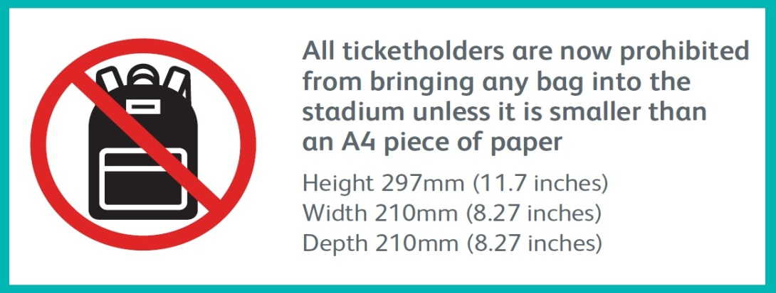  - All match day merchandise purchased from Wembley Stadium Store will be supplied in clear plastic bags and will still be admissible  - The new restricted bag policy has been introduced to further enhance public safety and to make accessibility on event days much more efficient. The new policy will enable fans to move through the stadium turnstiles much faster and benefit from enhanced safety inside and outside the stadium. For more information and to read our FAQ’s visit http://www.wembleystadium.com/plan-your-visit/stadium-guide/restricted-bag-policy  - Be aware of prohibited items. A full list of prohibited items can be found here Wembley Stadium - Ground Regulations.  - Food and drink – Visitors are advised not to bring food and drink  to the stadium as there will be sufficient provision inside for purchase. Please note that re-usable sports bottles are not permitted into the Stadium, all bottles must be disposable.  - Please note persistent standing is not permitted within the stadium bowl during the match. Wembley Stadium would kindly ask all supporters to abide by this rule and respond to the safety instructions from the stewarding team so that all guests can have an enjoyable experience.  - Discriminatory abuse, chanting or harassment of any kind is strictly forbidden and will result in arrest and/or ejection from the Ground. WNSL may impose a ban from the Ground as a result.  We thank all supporters for their cooperation and understanding.
ALCOHOL | No alcohol will be permitted entry if brought to the stadium. Full concessions will be available inside the stadium including alcohol to be purchased with the following management plan in place:  - No alcohol to be taken inside the bowl  - 4 x drinks per person at time of service  - Challenge 25 will be in force. Please bring proof of ID to show you are over 18 in order to purchase alcohol
FLAGS/BANNERS | Supporters may bring a flag/banner into the ground WITHOUT permission from Wembley Stadium if:  - The flag/banner is smaller than 250cm in size at the widest or longest point.  - It does not have an attached flag pole  - In the case of an attached flag pole, it is made from wood and plastic only and is no longer than 1 metre in length and 1cm in diameter.  - There is no advertising or commercial message on the flag  - It does not contain any abusive or defamatory message  Please note that flag poles made of metal are not permitted inside the stadium, no matter what size or length the flag / pole is.  If a supporter arrives at Wembley Stadium and their flag/banner does not come under the above points, and they have not gained permission from Wembley Stadium, the flag may be confiscated at the turnstiles and refused entry.  Supporters will NEED permission from Wembley Stadium if any of the following applies:  - Flag/banner is larger than 250cm in size at the widest or longest point  - The supporter wishes to have a static flag/banner connected to seating (this is not possible for sold out games)  Supporters wish to have a moving flag / banner over supporters’ heads, pre match (see below guidelines)  Upon seeking permission, you must supply the following:  - Submit an official request via help.wembleystadium.com/support/home  - A photo showing the whole of the flag  - A photo showing any flag pole connected  - The actual size of the flag  - A valid, in date fire certificate, in English with the appropriate stamps of authority (this is preferable but not mandatory)  If you arrive at Wembley Stadium and your flag differs in any way from the photographed or described flag, your flag may be confiscated at the turnstiles and refused entry into the Stadium.  Wembley Stadium reserves the right to remove any flags if they are deemed to be causing an issue during the match.
GUEST SERVICES | Connectors  Connectors are the dedicated team to ensure all guests to Wembley Stadium have a positive and memorable experience. They will be conveniently located throughout the venue and at Wembley Park station wearing bright yellow. This team are in place to provide support and knowledge to enhance the experience of all guests and ensure they can locate their seat, gate or transport hub. If you seek advice or assistance on event day, please locate a Connector.  Accessible shuttle  There will be an accessible shuttle operating between Wembley Park Tube Station and Wembley Stadium that can be utilised by any high needs guests. Wheelchair users, families with young children or anyone with difficulty walking long distances are encouraged to utilise this service.  *The shuttle will be operational from 13:30 – 20:45*  Young Person Wristbands  As a safeguarding service, Wembley Stadium provides ‘Young Visitor Wristbands’ to assist in the event of a lost child. To collect a young visitor wristband please visit your nearest information point.  Re-Entry  Should spectators leave the Stadium, they will not be allowed to re-enter, unless under exceptional circumstances such as on medical grounds. Please seek the support of a safety steward if this situation arises.
TRAVEL | Please note Wembley Stadium is a public transport destination and is well catered for with public services, which is the recommended mode of transport to and from the stadium. Below is a list of transport options for supporters:  TRAIN AND TUBE  London Underground  - Wembley Park Tube – 5 mins walk from stadium  (Metropolitan Line direct to Baker Street /  Jubilee Line direct to Baker Street and Bond Street)  - Wembley Central - Tube – 15 mins walk from stadium  (Bakerloo Line direct to Marylebone, Baker Street and Oxford Circus)  London Overground  - Wembley Central - 15 mins walk from stadium  (Overground to Euston)  - Wembley Stadium Station – 5 mins walk from stadium  (Chiltern Railways direct to London Marylebone)  Please be sure to plan your journey in advance via https://tfl.gov.uk/plan-a-journey/  COACH  National Express is the Official Coach Supplier for Wembley Stadium connected by EE and provides dedicated links for visitors to the stadium. Book your coach tickets for match day from over 55 locations across the UK by visiting National Express or by calling 08717 81 81 81.  CAR  For supporters wishing to drive please note there will be very limited spaces available at the stadium. Therefore we would strongly advise the use of public transport. If parking is required please book well in advance via Wembley Official Parking to guarantee your parking space. Blue badge parking is available to purchase via Wembley Official Parking .  The following car parks are available:  Vehicle Type Area  Cars / Coaches / Motorbikes Yellow Car Park  Cars / Motorbikes Red Car Park  Coaches Orange Car Park  Coaches York House  Please note that local road closures will be in place around the stadium on match day approximately 4 hours prior to kick off so plan travel accordingly.  BUS  Local buses to the Stadium include 18, 83, 92 and 224.  Please note that London buses no longer accept cash, therefore any supporters travelling by bus will need to pay for the fare using an Oyster card or contact less payment card. A single adult fare is £1.50.  For London tube, road, bus and other services please visit www.tfl.gov.uk. Find train times and fares at http://www.nationalrail.co.uk/ or call 0871 200 4950.

